Holistic Early Stage Prognostic Model: Nodal Groups

Created by A Rodday, 5/24/23

Contents

* Description of nodal groups
* Univariate relationship between nodal groups & 5y PFS
* Histology (distribution & univariable)
* Spline results for age
* Maximum tumor diameter distribution

Eligibility criteria unless otherwise specified:

Age 18-65y; cHL; early stage disease; no out of range lab values (albumin 1-6; ESR >=1; hemoglobin 5-16.5; lymphocyte count 0.1-5; WBC count 0.1-50); no above & below diaphragm disease; no Waldeyer’s ring only; no count of 0 nodal groups (looking above & below diaphragm); missing <50% of candidate predictors. Registries further restricted to: treated with curative intent; not treated on a trial; diagnosed 1996 to 2019.

Table 1. Nodal Locations by Study Type a

|  |  |  |
| --- | --- | --- |
|  | Trials, n=3108 | PMH, n=481 |
| Nodal locations -- select all, n (%) |  |  |
| Nodal location: L/R Cerv, Supralav, Occip | 2535 (81.6%) | 338 (70.3%) |
| Nodal location: L/R InfraClav, Pec, Axilla | 673 (21.7%) | 90 (18.7%) |
| Nodal location: Mediastinum, Hilum | 2289 (73.6%) | 380 (79.0%) |
| Nodal locations – mutually exclusive, n (%) |  |  |
| Cerv/Supralav/Occip ONLY | 614 (19.8%) | 73 (15.2%) |
| InfraClav/Pec/Axilla ONLY | 78 (2.5%) | 6 (1.2%) |
| Mediastinum/Hilum ONLY | 418 (13.4%) | 120 (24.9%) |
| Cerv/Supralav/Occip AND InfraClav/Pec/Axilla | 107 (3.4%) | 9 (1.9%) |
| Cerv/Supralav/Occip AND Mediastinum/Hilum | 1383 (44.5%) | 185 (38.5%) |
| InfraClav/Pec/Axilla AND Mediastinum/Hilum | 57 (1.8%) | 4 (0.8%) |
| All 3 | 431 (13.9%) | 71 (14.8%) |

a Restricted to eligibility (see page 1). Not based on multiple imputation

Table 2. Univariate results for nodal locations for 5y PFS for development cohort a

|  |  |  |
| --- | --- | --- |
|  | **Univariable** | |
| **HR (95% CI)** | **p-value** |
| Nodal locations -- select all |  |  |
| Nodal location: L/R Cerv, Supralav, Occip | 0.63 (0.48, 0.83) | <0.01 |
| Nodal location: L/R InfraClav, Pec, Axilla | 1.48 (1.14, 1.93) | <0.01 |
| Nodal location: Mediastinum, Hilum | 1.31 (0.98, 1.76) | 0.07 |
| Nodal locations – mutually exclusive |  |  |
| Cerv/Supralav/Occip ONLY | reference |  |
| InfraClav/Pec/Axilla ONLY | 2.37 (1.17, 4.81) | 0.02 |
| Mediastinum/Hilum ONLY | 2.09 (1.33, 3.27) | <0.01 |
| Cerv/Supralav/Occip AND InfraClav/Pec/Axilla | 2.59 (1.40, 4.76) | <0.01 |
| Cerv/Supralav/Occip AND Mediastinum/Hilum | 1.56 (1.06, 2.30) | 0.02 |
| InfraClav/Pec/Axilla AND Mediastinum/Hilum | 4.82 (2.54, 9.16) | <0.01 |
| All 3 | 1.79 (1.13, 2.84) | 0.01 |

a Restricted to eligibility (see page 1). Not based on multiple imputation

Table 3. Distribution of histology

|  |  |  |
| --- | --- | --- |
|  | **Development, n=3138** | **Validation, n=481** |
| Study/Registry |  |  |
| NCIC | 284 (9.1%) |  |
| H10 | 1791 (57.1%) |  |
| H9U | 692 (22.1%) |  |
| RAPID | 371 (11.8%) |  |
| PMR |  | 481 (41.1%) |
| ~~Iowa/Mayo~~ |  |  |
| ~~Australia~~ |  |  |
| ~~BC Cancer~~ |  |  |
| Histology, n (%) |  |  |
| Lymph Depleted | 21 (0.7%) | 0 |
| Lymph Rich | 104 (3.3%) | 12 (2.5%) |
| Mixed Cellularity | 432 (13.8%) | 20 (4.2%) |
| Nodular Sclerosis | 2519 (80.3%) | 410 (85.2%) |
| NOS | 63 (2.0%) | 39 (8.1%) |

a Restricted to eligibility (see page 1). Results are based on multiple imputation

Table 4. Univariate results for histology for 5y PFS for development cohort a

|  |  |  |
| --- | --- | --- |
|  | **Univariable** | |
| **HR (95% CI)** | **p-value** |
| Histology |  |  |
| Lymph Depleted | 2.08 (0.66, 6.56) | 0.21 |
| Lymph Rich | 0.52 (0.19, 1.39) | 0.19 |
| Mixed Cellularity | 1.17 (0.85, 1.63) | 0.34 |
| Nodular Sclerosis | reference |  |
| NOS | 1.88 (0.95, 3.70) | 0.07 |

a Restricted to eligibility (see page 1). Results are based on multiple imputation

Age relationship with 5y PFS for development cohort a

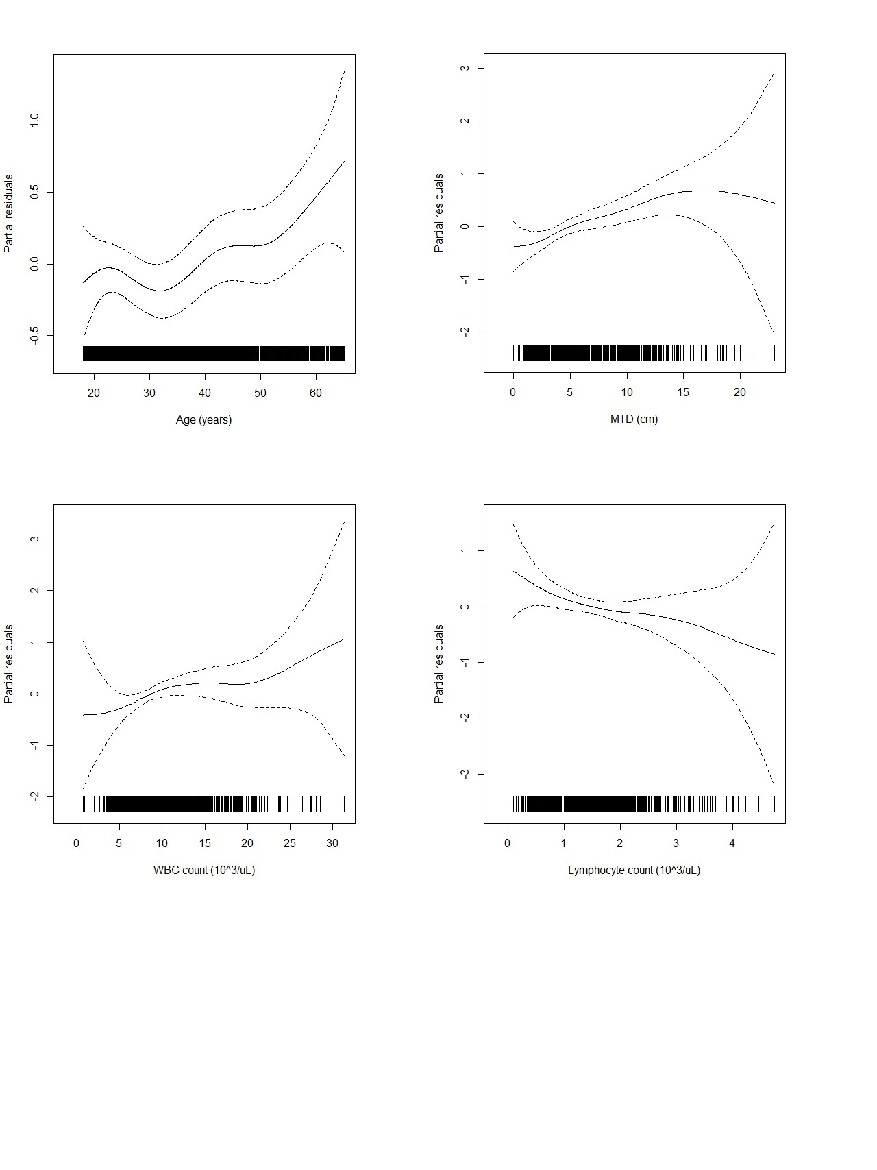

|  |  |
| --- | --- |
|  | Summary Statistics |
| Age (years), mean (SD) | 34.6 (12.3) |
| Age (years), median (Q1, Q3) | 31.4 (24.3, 43.2) |
| Age binary, n (%) |  |
| <30y | 1417 (45.2%) |
| ≥30y | 1721 (54.8%) |
|  | HR (95% CI), p-value for 5y PFS |
| Age (continuous) | 1.01 (1.00, 1.02), p=0.07 |
| Age spline |  |
| Age effect <30y | 0.98 (0.91, 1.06), p=0.68 |
| Age effect ≥30y | 1.05 (1.02, 1.07), p<0.01 |

a Restricted to eligibility (see page 1). Results are based on multiple imputation

Maximum tumor diameter for development cohort and relationship with 5y PFS a

|  |  |
| --- | --- |
|  | Summary Statistics |
| MTD (cm), mean (SD) | 5.5 (3.5) |
| MTD (cm), median (Q1, Q3) | 4.8 (3.0, 7.4) |
| MTD (cm), min, max | 0, 23 |
| MTD binary, n (%) |  |
| ≤15 | 3104 (98.9) |
| >15 | 34 (1.1) |

a Restricted to eligibility (see page 1). Results are based on multiple imputation

